Architecture Solution Design

OneTrust, Document Scanning – Assessment Automation Solution Design
[RITM1149048 | ACBSD-4272]

Version Control
Version Control |  |  |  |  | Approvals
Version | Date | Author/  Updated By: | Status | Comment | Pre-ARB | GTS ARB | Global ARB | GITB
01 | 2017-09-27 | M. Rijkers | Initial Document
02.00.00 | 2025-12-09 | Mohamed Kerbachi | Initial Document | Use new document template and add AI features | ☐ | ☐ | ☐ | ☐

Table of Contents
Version Control 2
Table of Contents 3
1. Distribution and Contacts 6
2. Artifacts 7
3. Summary 8
3.1 Background 8
3.2 Solution Description 8
3.3 Business Unit(s) Impacted 8
4. Requirements 9
4.1 Use Cases 9
4.1.1 Use Case Requirements 9
4.1.2 Business Requirements 9
4.2 Functional Requirements 9
4.3 Non-Functional Requirements 10
Observability, Logging and Monitoring Requirements 10
Fault Tolerance & Resiliency Requirements 10
Availability Objectives 10
Performance Requirements 10
Capacity Requirements 10
4.4 Security Requirements 11
Security Requirement 11
4.5 Data Requirements 11
Data Requirement 11
4.6 Capability Map 11
5. Architecture 12
5.1 Alignment to Principles 12
5.2 Baseline Architecture 13
5.3 Target Architecture 14
5.3.1 Overview 14
5.3.2 Technology Components & Architecture Impacts 14
5.3.3 Gap Analysis 15
6. Components 16
6.1 Components or Patterns Used 16
6.1.1 Component Architecture Diagram 17
6.1.2 Components or Pattern Table 17
6.2 Integration Architecture 18
6.2.1 Integration Architecture Diagram 18
6.2.2 Integration Architecture Table 18
6.3 Data Flow 18
6.3.1 Data Flow Diagram 19
6.3.2 Data Flow Table 19
6.4 Data Protection 20
6.4.1 Backup and Recovery 20
6.4.2 High Availability 20
6.4.3 Disaster Recovery 20
6.5 Observability 20
6.6 Authentication and Authorization 20
6.7 Security Boundaries 20
6.7.1 Security Boundaries Diagram 20
6.7.2 Security Boundaries Table 21
6.7.3 Security Review Outcomes 21
6.7.4 Threat Model Assessment 21
7. Data Solution 22
7.1 Data Classification 22
7.2 Privacy Impact Assessment (PIA) 22
7.3 Data Encryption 22
7.4 Data Retention 22
7.5 Data Residency 22
7.6 GenAI 22
8. Service Model 24
8.1 Shared Responsibilities 24
8.2 RACI Chart 24
9. Implementation Approach 26
9.1 Proposed level of coordination 26
9.2 Dependencies 26
10. Waivers and/or Exceptions 28
10.1 Risk Acceptances 28
10.2 Risk Remediations 28
10.3 Security Exceptions 28
11. Estimated Costs 30
11.1 Financial Considerations 30
11.2 Non-Financial Considerations 30
11.3 Cost Benefit Analysis 30
11.4 Licensing 31
11.5 Financial Assumptions 31
11.6 Resourcing Considerations 31
12. Exit Strategy 32

Distribution and Contacts
Use confluence link to find contacts for the below section. Delete red text when done.
Link: ISO, DPO and Architects - GTS Architecture Solution Design - Global IT Confluence Production (aegon.com)
This document and future updates to be shared with the business representatives shown below.
Business Contacts and Information
Requester | Emma Warner
Business DPO | Emma Warner
Business ISO | Nick Russell & Daniel Lartey
Business Architect | Mohamed Kerbachi, Neil Everest
BCP Manager | N/A
Business Unit | Data protection office
Cost Center | N/A
Cost Center Owner | N/A
Product / Service Owner | Emma Warner
GTS Contacts and Information
GTS DPO | Adam Kaminski & Emma Warner
GTS ISO | Nick Russell & Daniel Lartey
GTS Architecture | Mohamed Kerbachi
GTS Technology Risk Assessment | Rachel Singewald,
GTS/Corp Centre GenAI Working Group | Guy Dye

Artifacts
Review Process and Acknowledgements
In Scope | Owner | Non-Architecture Review / Assessment Process | Point of Contact(s) | Link to Acknowledgement or Evidence
☐ | First Line Risk & Controls | Technology Risk Assessment (only for Core and Common designs) | Rachel Singewald, Matyas Vajda | Link
☐ | GTS – Information Security | Information Security Review (process in development and will replace security review section) | Nick Russel, Daniel Lartey | Link
☐ | GTS – Information Security | Threat Model | Paul Nickelson, Jeff Bain | Link
☐ | Data Privacy | Data Privacy Impact Assessment (OneTrust) | Emma Warner, Adam Kaminski | DPIA Number # 12549
☐ | GTS - Architecture | Approved Architectural Artifacts Added to Architecture Repository | Mohamed Kerbachi | Link to Repo
☐ | GTS/Corp Centre GenAI | GenAI Inventory & Working Group Communication | Guy Dye | GenAI Inventory ID # CC0040 / GTS021

Architecture review checklist
Role | Name | Status
Architect | Neil Everest | Not read
 |  | Not read

Stakeholders review checklist
Role | Name | Status
GTS DPO | Emma Warner | Approved
OneTrust PO | David Megellai | Approved
GTS ISO | Nick Russell or Daniel Lartey | Not read
GTS Technology Risk Assessment | Rachel Singewald or Juan Irizarry | Not read
Cloud Infrastructure | John Drummond or John Hegyi | Not read

Summary

Background
This document is an update of the previous OneTrust Solution Design created in 2017 September the 27th. The link to the document: ERM000000321858 Solution Design - OneTrust for Aida (GDPR).docx
As Aegon expands its digital footprint and operates under increasingly complex privacy and security regulations, the business's need for a unified data governance and compliance platform becomes critical. OneTrust directly addresses this need by streamlining regulatory compliance, reducing legal exposure, and eliminating the manual effort and cost associated with managing data privacy, Privacy Impact Assessment (PIA) and Data Protection Impact Assessment (DPIA) for all processes containing customer or employee data, consent, and vendor risk across fragmented systems. Key drivers include growing regulatory pressure (GDPR, CCPA, HIPAA), rising expectations for data transparency, increased vendor reliance, and the need for scalable governance.
OneTrust resolves these challenges by providing a centralized, SaaS-based framework that ensures consistent, efficient, and accountable data governance across the entire organization.

Solution Description
OneTrust privacy management software platform helps organizations meet their legal and operational requirements by automating Privacy Impact Assessments and data mapping, identifying privacy risks, and enforcing risk management activities in an integrated platform.
OneTrust is SAAS solution. The connection from the user’s browser to the SaaS application follows a standard web‑browsing pattern. The application supports SAML-based authentication via PingOne and is currently integrated with PingOne as its identity solution.
The solution is hosted in OneTrust’s dedicated cloud tenant in the Frankfurt region

Vendor URL: https://onetrust.com/

Default two stages will be used:

• User Acceptance Testing
• Production / Live

Business Unit(s) Impacted
The following Country/Business Unit(s) will be impacted by this Solution Design:
☐ | TA | ☐ | GTS | ☐ | Spain
☐ | UK | ☐ | HR Global | ☐ | TLB
☐ | NL | ☐ | ASIA/TLB | ☒ | Global
☒ | Corporate Centre | ☐ | AAM | ☐

Requirements

Business Requirements
Business Requirements
Req. # | Requirement Details | Priority
BR. 1.0 | Exit Strategy: export all data in industry format | Must Have
BR. 2.0 | Regulation compliance: GDPR, UK GDPR, CCPA, HIPAA | Must Have
BR. 3.0 |  | Could Have

Functional Requirements
Functional Requirements
Req. # | Req. Category | Requirement Details | Priority
FR.1.0 | Technology component | Audit and Reporting – Generate compliance reports and maintain audit trails for all activities | Must Have
FR.2.0 | Risk | Risk Identification and Mitigation – Detect privacy risks and enforce remediation workflows. | Must Have
FR.3.0 | Risk | Vendor Risk Management – Assess and monitor third-party vendor compliance and risk. | Must Have

Non-Functional Requirements
Non-Functional Requirements
Req. # | Req. Category | Requirement Details | Priority
NFR.1.0 | Observability, Logging and Monitoring Requirements | Compatibility and connectivity with corporate approved SIEM (Splunk) | Must Have
NFR.2.0 | Fault Tolerance & Resiliency Requirements | OneTrust is a Tier 2 application with RPO 12, RTO 24 | Must Have
NFR.3.0 | Availability Objectives | OneTrust is SaaS solution and comply with Aegon requirements | Must Have
NFR.4.0 | Performance Requirements | OneTrust is SaaS solution and comply with Aegon requirements | Should Have
NFR.5.0 | Capacity Requirements | OneTrust is SaaS solution and comply with Aegon requirements | Should Have

Security Requirements
Security Requirements
Req. # | Req. Category | Requirement Details | Priority
SR.1.0 | Security Requirement | Authentication with PingOne | Must Have
SR.2.0 | Security Requirement | Corporate Intra ID based authorization | Must Have
SR.3.0 | Authorization | Role-Based access Control

Data Requirements
Data Requirements
Req. # | Req. Category | Requirement Details | Priority
DR.1.0 | Data Requirement | Data Retention: Archiving data older than 5 years | Must Have
DR.2.0 | Data Requirement | The provider (OneTrust) does not use company data for LLM training. | Must Have

Architecture

Alignment to Principles
Alignment to architecture principles: Architecture Principles (sharepoint.com)

Architecture Principles Alignment |  | Justification for lack of alignment (or a comment)
☒ | Capability Driven
☒ | Data Excellence
☒ | Modern
☒ | Secure and Compliant
☒ | Transparent
☒ | Future Proof
☒ | Reliable
☒ | Interoperable
☒ | Standardized
☒ | Value Oriented

Target Architecture

Overview

The existing architecture of the OneTrust platform relies primarily on manual processes for interpreting documents and completing compliance assessments. While effective to a degree, this approach demands significant human effort, slows down workflows, and may lead to inconsistencies or reduced accuracy in meeting compliance standards. The platform functions as a centralized tool for managing compliance but lacks advanced automation capabilities that could streamline operations and improve scalability.

The target architecture introduces a new AI-powered module designed to enhance the platform’s capabilities. This includes the integration of a Copilot Chatbot and a Document Scanner, both aimed at automating document interpretation and supporting users throughout the compliance assessment process. The goal is to improve accuracy, reduce manual workload, and accelerate compliance workflows, while ensuring alignment with evolving regulatory requirements.

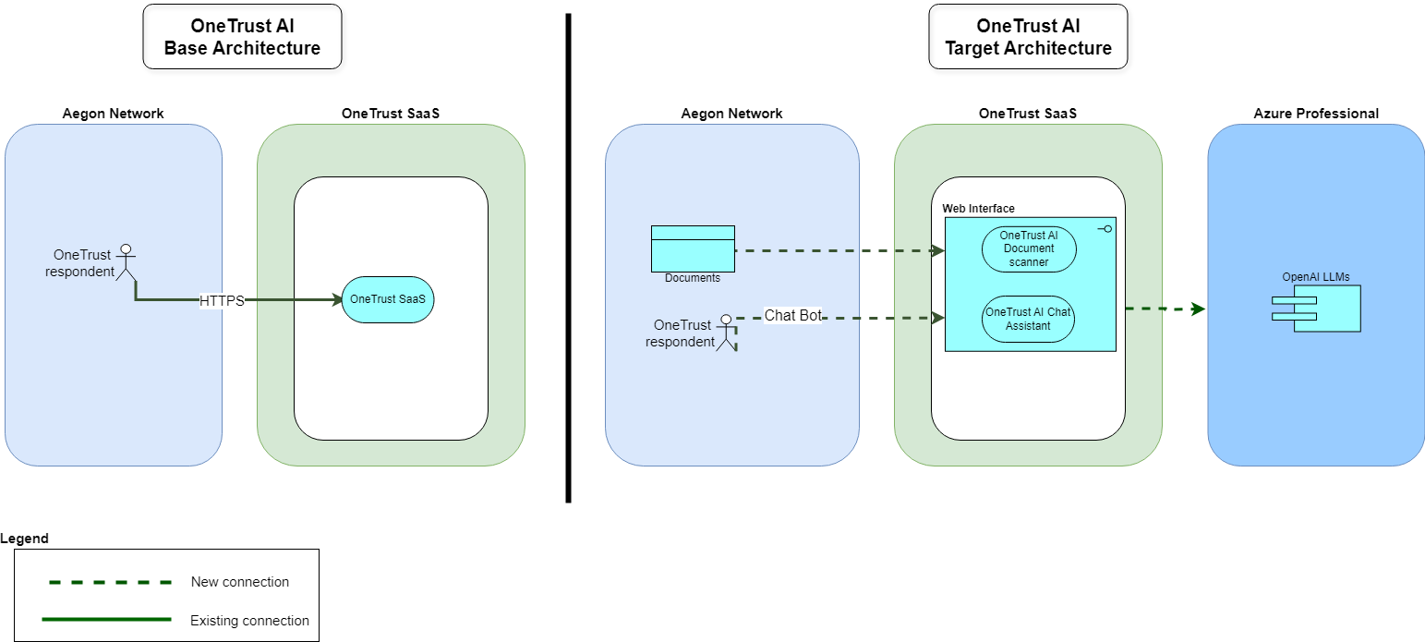

Technology Components & Architecture Impacts
List the technology components impacted by the change.
Technology Component Type | Technology Component Name | CMDB ID | Architecture Impact | Tech Lifecycle Strategy | Application Risk Rating
Business Application, Software, Hardware, Cloud Component | Application Name, Software Name, Hardware Name, Cloud Component Name | CMDB ID if in the CMDB  If not in the CMDB, indicate ‘New’  Prior to Project Solution - Final ARB, ‘New’ items must have a CMDB id to receive a passing score within the Architecture Alignment to Standards scorecard | Replace, Decom, Migrate, Re-use, Enhance, New | Buy, Hold, Sell  This is located in the Application IT Compliance Data in CMDB.  Search for the application an select the latest UPDATED date. The Application Lifecycle Strategy is on the right | Application Risk Rating is found by clicking on the link within the Application IT Compliance Data tab at the bottom of the application’s CMDB entry
Business Application | ONETRUST GLOBAL | CI001936362 | Reuse | Buy | LOW

Gap Analysis
Copilot Chatbot and Document Scanner modules will be available to all platform users as part of OneTrust’s new licensing model and can be enabled as optional features.

Components

Component Architecture Diagram

OneTrust solution uses two existing component patterns as described in the diagram:

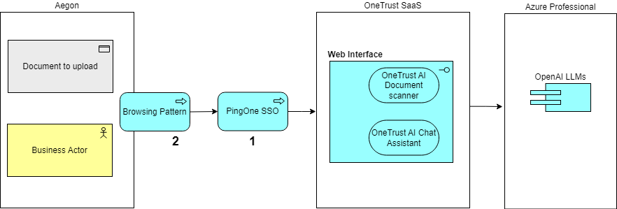

Components or Pattern Table
Components/Patterns Used |  | Link | Version
1 | PingOne
2 | Browsing Pattern

Data Flow

Data Flow Diagram

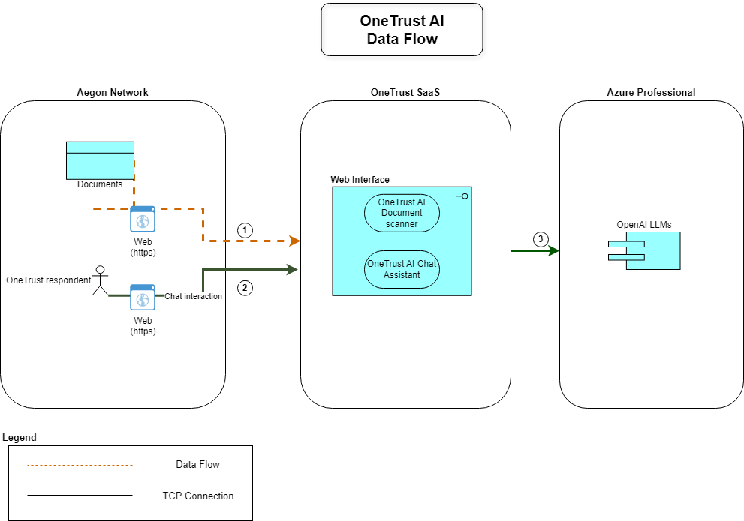

Data Flow Table
Data Flow Reference |  | Description
1 | Document upload to OneTrust User interface | The respondent can upload the document to OneTrust using the OneTrust web portal (HTTPS TLS v1.2+).
2 | Chat interaction | The respondent can interact with the OneTrust AI chat assistant available in OneTrust web portal (HTTPS TLS v1.2+).
3 | LLMs models hosted on Azure professional | All LLMs queries are sent to OneTrust’s Azure professional subscription.

Authentication and Authorization
OneTrust authentication is enabled with PingOne Single Sign On (SSO) and authorization with users and groups of Corporate Entra ID.

Security Boundaries
OneTrust users connect only from Aegon corporate network. Document uploads and login requests follow the standard Aegon browsing pattern, ensuring compliance with approved security practices. Authentication is secured through PingOne Single Sign-On (SSO), which enforces identity verification and aligns with Aegon established authentication framework.

Security Boundaries Diagram
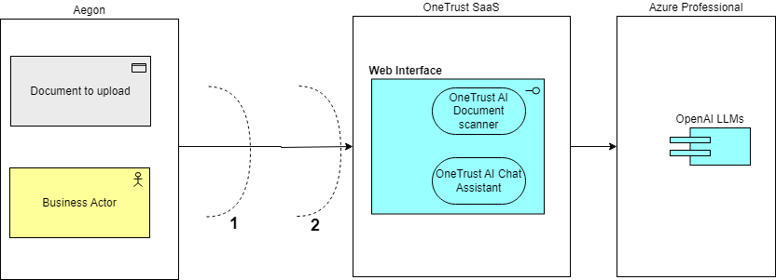

Security Boundaries Table
Security Boundary Reference |  | Existing Pattern | Description
1 |  | Corporate Firewall
2 |  | PingOne SSO

Security Review Outcomes
Detail any significant outcomes, risks or recommendations highlighted in the security review (GTS ISO).
Text

Threat Model Assessment
If a Threat Model Assessment is needed, please complete this section/activity.
Open a Service Request to have a Threat Model Assessment Completed. Include this document and any supporting documented in the service request. After the assessment is complete, return to this document and modify the design/controls/governance to account for proper mitigation of the threats.

Data Solution

Data Classification

☐ | Strictly Confidential |  | ☐ |  | Financial Information
☐ | Confidential |  | ☐ |  | Personal Identifiable Information
☒ | Internal |  | ☐ |  | Protected Health Information
☐ | Public |  | ☐ |  | Payment Card Information
☐ | No Data Shared |  | ☒ |  | No Personal Data Shared*
- Note for “No Personal Data Shared": the only personal data processed in one trust is user credentials for access, creation and approval of assessments

Privacy Impact Assessment - PIA #12549

Data Encryption

All data in transit is encrypted using SSL/TLS protocols, with TLS 1.2 as the minimum standard.
The following table outlines the supported Transport Layer Security (TLS) protocols with applicable ciphers for OneTrust's cloud environments as of June 6, 2023:
Protocol | Applicable Ciphers
TLS 1.2 | TLS_ECDHE_ECDSA_WITH_AES_256_GCM_SHA384  TLS_ECDHE_ECDSA_WITH_AES_128_GCM_SHA256  TLS_ECDHE_RSA_WITH_AES_256_GCM_SHA384  TLS_ECDHE_RSA_WITH_AES_128_GCM_SHA256
TLS 1.3 | AEAD-AES128-GCM-SHA256  AEAD-AES256-GCM-SHA384  AEAD-CHACHA20-POLY1305-SHA256

Data Retention

Data retention policy in OneTrust is defined as follow:

Data Category | Sub-Category | Type of record ( try and incl example) | PII / Personal Data | Special Category or Strictly Confidential PII (PHI, PFI) | Requires Attestation | Statutory / Legal | Data Source | Retention Period
DPO | Data Protection Impact Assessments |  | No | No | No | No | One Trust | 6 years following archive archived

Data Residency
The OneTrust AI modules—Copilot Chatbot and Document Scanner—are hosted in the same location as the OneTrust application and will be accessed through that environment.
OneTrust Application Environment | Data Center Hosting Location | Primary Hosting Location | Disaster Recovery Hosting Location | Admin Portal IP Addresses
uat-de.onetrust.com | Germany | Frankfurt | Berlin | - 20.52.206.176/30  - 51.116.81.232/30
app-de.onetrust.com | Germany | Frankfurt | Berlin | - 20.52.206.176/30  - 51.116.81.232/30

GenAI
The two GenAI related features available for OneTrust are AI Chat Assistant and Document Scanner. The specifications are detailed in the following tables.

AI feature: OneTrust Copilot (AI Chat Assistant)
Purpose | Conversational chatbot that answers customers’ custom questions about global laws and regulations and how to use the OneTrust platform. Responses are generated from my.OneTrust product documentation and proprietary OneTrust DataGuidance research data. By delivering customized answers to specific customer questions, this AI feature saves customers time on research and finding information across sources.
Methodology | Which model is used?  Azure OpenAI text-embedding-3-small (third-party), and Azure OpenAI GPT-4 variants (third-party)  How does it work?  A retrieval-augmented generation (RAG) technique converts DataGuidance and my.OneTrust data into vector representations using Azure OpenAI text-embedding-3-small and then compares the data to find relevant responses to the user's question.  Training Data  None.
Data Processed | myOneTrust product documentation and DataGuidance research data is used.  Customer input is processed exclusively to execute the model
Controls | Default: On  Option to disable: Yes

AI feature: Document Scanner
Solution(s) and Product(s) | Third-Party Management: Third Party Risk Management  Privacy Automation: Assessment Automation
Purpose | Automatically populates assessment questionnaires with suggested responses using information in documents uploaded and scanned by the customer such as a project summary, contract, or SOC2 report. Saves the customer time and reduces customers’ manual effort by auto-filling assessments using insights from documents added by the customer
Methodology | Which model is used?  Azure OpenAI ada-embedding-002 (third-party), andAzure OpenAI GPT-4 variants (third-party)  How does it work?  Retrieval augmented generation (RAG) is used for this functionality. Uploaded documents are turned into vector representations using Azure OpenAI ada-embedding-002 and compared to find the ones relevant to the user's assessment question.  Training Data  None.
Data Processed | Customer data in the form of documents that the customer chooses to upload during an assessment
Controls | Default: On  Option to disable: Yes

Service Model
OneTrust is a fully hosted and managed cloud solution that delivers its application without requiring any customer-owned infrastructure. The provider, OneTrust, is solely responsible for the entire operational health, security, and performance of the platform. The end-to-end management ensures data safety, system availability, and seamless application functionality for all users.
Shared Responsibilities
OneTrust, as the provider, is responsible for the security and operation of the cloud platform itself. This includes all physical infrastructure, network controls, application hosting, data encryption at rest and in transit, and compliance for the underlying service.
Aegon as a subscriber, is responsible for security and operations in the cloud.

Privacy Officers are high-level users who have access to most functions in the application. By default, Privacy Officer users do not have access to administrative and destructive functions such as audit logging, deletion, and integrations.

Site admins are responsible for managing the OneTrust application for the organization. Users with this role at the root organization level have complete access to the application with all permissions enabled by default. Site admins within lower organizations in the hierarchy will have access to most permissions at their organizational group and below.

Estimated Costs
N/A

Licensing
The licensing model is based on elevated users (DPOs + Administrators, and the ‘implementation’ is essentially turning the embedded functionality on

Financial Assumptions
NA

Resourcing Considerations
NA

Exit Strategy
Aegon has the capability to export data from OneTrust upon request, ensuring flexibility for compliance and reporting needs.

